L38 — LOG DETECTIVE
Linux Shell Scripting Mini-Project Report
Project Title: Log Detective — Web Server Log Analyzer
Submitted By: srushti Sejal Ben vala
Course / Class: IMCA / G
Roll Number: E35
Submitted To: Anjum Mansuri
Submission Date: __________________________

PAGE 1 — INTRODUCTION
1. Introduction
Log Detective is a Linux shell scripting mini-project designed to analyze web server access logs. It provides a menu-driven interface that helps users understand website traffic by examining IP addresses, HTTP status codes, requested pages, and error requests.
The project is developed using Bash shell scripting and standard Linux command-line utilities. It also includes features for viewing log data, creating compressed backups, maintaining an activity log, and generating a traffic report.
2. Objectives
The main objectives of this project are:
- To understand Linux shell scripting.
- To analyze web server access logs.
- To identify frequently used IP addresses and requested pages.
- To count different HTTP status codes.
- To identify pages returning 404 errors.
- To generate requests-per-hour reports.
- To create compressed backups of project data.
- To record activities and demonstrate scheduled report generation.
3. Tools and Technologies
- Operating System: Ubuntu Linux using Windows Subsystem for Linux (WSL)
- Scripting Language: Bash
- Text Processing: AWK
- Linux Commands: sort, uniq, head, tail, less
- Backup Utility: tar
- Scheduling Utility: cron
4. Project Objective Statement
The purpose of Log Detective is to simplify the analysis of web server logs through a menu-driven shell script. It helps users identify traffic patterns, examine HTTP errors, maintain activity records, and create backups using basic Linux utilities.

PAGE 2 — PROJECT STRUCTURE AND FEATURES
5. Project Structure
The project is stored in the directory:
~/linux_project/logdetective
The main files and directories are:
1. main.sh: Contains the main menu and calls the selected function.
2. lib/functions.sh: Contains functions for log analysis, data backup, activity logging, and traffic report generation.
3. data/access.log: Contains sample web server access-log entries used for testing.
4. logs/activity.log: Stores records of feature usage, backup creation, and cron task execution.
5. reports/traffic.log: Stores the output of the traffic-report command.
6. backups/: Stores compressed backup files in tar.gz format.
7. README.md: Contains the project description, features, directory structure, and execution instructions.
6. Main Features
Feature 1: Top 10 IP Addresses
This feature counts requests from each IP address and displays the ten IP addresses with the highest request counts.
Feature 2: HTTP Status Code Analysis
This feature counts HTTP status codes, such as 200, 301, 403, and 404, to summarize server responses.
Feature 3: Most Requested Pages
This feature identifies the most frequently requested pages by counting the requested paths in the access log.
Feature 4: 404 Pages List
This feature identifies pages that returned HTTP 404 errors, helping users find missing or unavailable pages.
Feature 5: Requests Per Hour
This feature groups log entries by date and hour to provide an overview of request activity.
Feature 6: View Data
This option opens the raw access log so that users can inspect individual log entries.
Feature 7: Backup Data
This option creates a compressed tar.gz archive containing the data directory.
Feature 8: View Activity Log
This option displays recent activity records, including feature usage and backup operations.
Additional Feature: Cron Report
The project includes a command that generates a report of the top three IP addresses for the current hour and appends the result to reports/traffic.log. Automatic hourly execution requires a configured and running cron service.

PAGE 3 — IMPLEMENTATION AND TESTING
7. Implementation
The project uses a menu-driven Bash script. The main script displays the available options and uses a case statement to call the appropriate function.
The supporting functions are stored in lib/functions.sh and loaded by main.sh.
AWK is used to extract fields from the access log. The sort and uniq commands are used to group repeated values and calculate counts. The head command limits the output to the required number of results.
The backup feature uses the tar utility with gzip compression. The activity logging function records the date, time, and description of each activity.
8. Testing and Results
The project was tested using a sample access log containing 200 entries.
Test 1 — Top 10 IP Addresses
The program displayed ten IP addresses with their request counts.
Test 2 — HTTP Status Codes
The output displayed the following counts:
- HTTP 200: 80 requests
- HTTP 301: 40 requests
- HTTP 403: 40 requests
- HTTP 404: 40 requests
Test 3 — Most Requested Pages
The program displayed the requested page paths and their counts.
Test 4 — 404 Pages List
The program identified /missing.html with 40 requests returning HTTP 404.
Test 5 — Requests Per Hour
The program grouped the sample log entries into an hourly report.
Test 6 — View Data
This option is provided to display the raw access log. Its final screenshot should be captured after testing the option.
Test 7 — Backup Data
The program successfully created a timestamped compressed backup file inside the backups/ directory.
Test 8 — View Activity Log
The activity log displayed feature usage records and the backup creation entry.
Cron Report Test
The cron command successfully generated a report file. After updating the sample timestamps, the report displayed the top three IP addresses for the current hour, with 20 requests each in the displayed sample.
9. Commands to Run the Project
Open Ubuntu and navigate to the project directory:
cd ~/linux_project/logdetective
Run the menu:
./main.sh
Display help:
./main.sh --help
Create a backup:
./main.sh --backup
Generate the traffic report:
./main.sh --cron

PAGE 4 — SCREENSHOTS
10. Screenshots of the Project
Screenshots provide visual evidence that the program and its features work as expected. Insert genuine screenshots captured from the Ubuntu terminal.
Screenshot 1: Main Menu
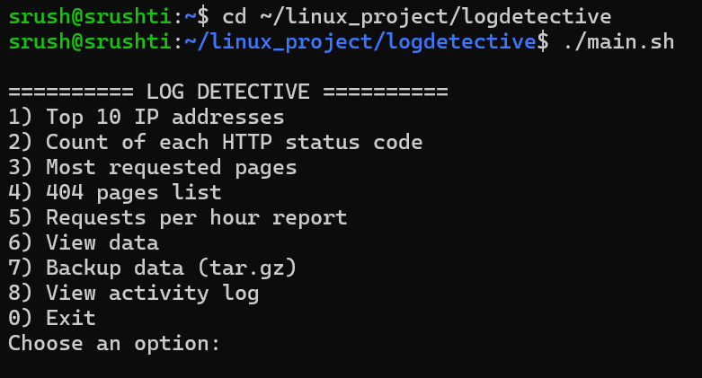
Description: This screenshot shows the menu-driven interface and the available project options.
Screenshot 2: Top 10 IP Addresses
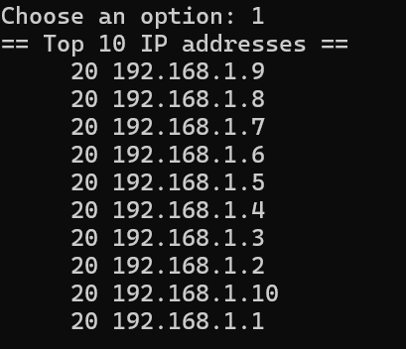
Description: This screenshot shows the IP addresses ranked by their request counts.
Screenshot 3: HTTP Status Code Analysis
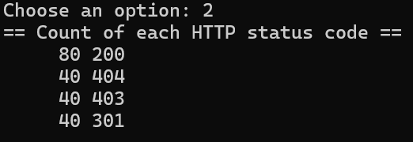
Description: This screenshot displays the number of requests for each HTTP status code.
Screenshot 4: Most Requested Pages
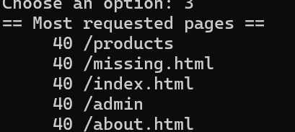
Description: This screenshot displays the most frequently requested page paths.
Screenshot 5: 404 Pages List
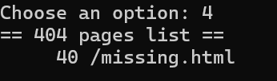
Description: This screenshot identifies pages that returned HTTP 404 errors.

PAGE 5 — REMAINING SCREENSHOTS AND CONCLUSION
Screenshot 6: Requests Per Hour
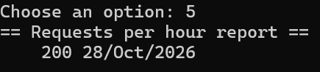
Description: This screenshot shows the hourly grouping of access-log requests.
Screenshot 7: View Data
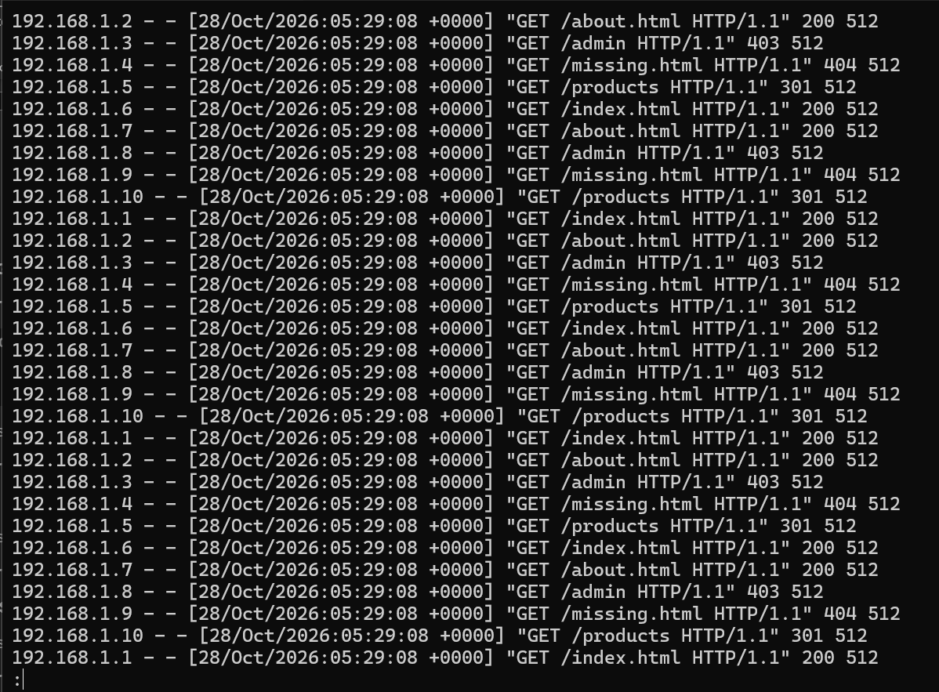
Description: This screenshot shows the raw access-log entries.
Description: This screenshot shows the successful creation of a compressed backup archive.
Screenshot 9: Activity Log
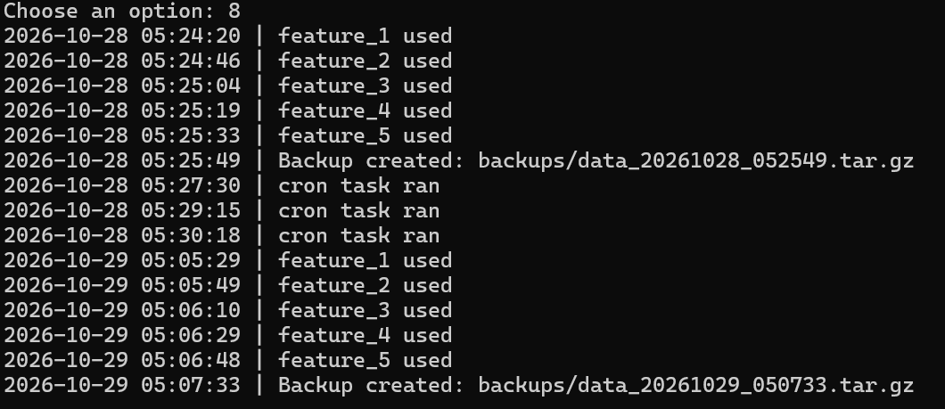
Description: This screenshot shows the recorded feature usage and backup activity.
11. Conclusion
Log Detective demonstrates the practical use of Linux shell scripting for web server log analysis. The project combines Bash functions and standard Linux utilities to analyze IP addresses, HTTP status codes, requested pages, and error requests.
It also demonstrates file viewing, compressed backups, activity logging, and traffic report generation. The project helped develop practical knowledge of Bash scripting, text processing, Linux file management, and command-line tools.
The project can be improved in the future by adding more detailed reports, configurable log files, improved error handling, and further automation.
12. Final Submission Checklist
- Project source files included.
- README.md included.
- Sample access log included.
- Backup archive included.
- Actual screenshots inserted.
- Student details completed.
- PDF report reviewed.
- Final submission archive created.

